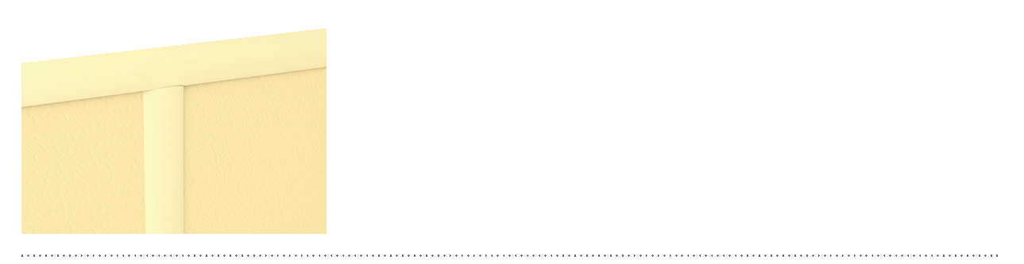
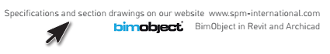
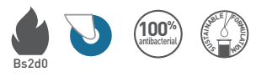

SPECIFICATION

FIN’COLOR – JOINTING PROFILE H SHAPE
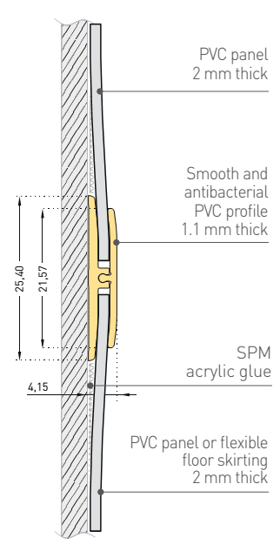
JOINTING PROFILE FOR 2 MM PANELS
DECOCHOC, DECOCLEAN, DECOWOOD ET DECOTREND PANELS

- Description: jointing profile (H shape) from antibacterial PVC achieving Bs2d0 fire rating with solid colour (Fin’Color jointing profile in H shape as manufactured by SPM) designed for horizontal or vertical jointing between 2 mm thick protection panels (Decochoc, Decoclean, Decowood or Decotrend as manufactured by SPM) or the connection of these panels with 2 mm flexible floor skirting. Smooth surface, 3 m long, 21.5 mm wide for the visible part.
- Environment: no heavy metals and no substance potentially subjected to any REACH restriction are used in its manufacture, nor PBT/BPA. The calcium-zinc thermal stabilization process is used. The emission level of volatile substance in inside air has been tested according to ISO 16000-6 and is very low (A+) according to the French regulation (23 March 2011 nr 2011-321 Decree and 19 April 2011 Order). 100% of the product are recyclable.
- Colours: selected by architects from manufacturer’s standard range.
- Installation method: glue as per manufacturer’s instructions.

SPECIFICATION

FIN’COLOR – FINISHING PROFILE J SHAPE
FINISHING PROFILE FOR 2 MM PANELS
DECOCHOC, DECOCLEAN, DECOWOOD ET DECOTREND PANELS
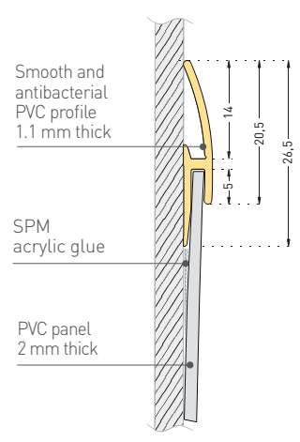
- Description: finishing profile (J shape) from antibacterial PVC achieving Bs2d0 fire rating with solid colour (Fin’Color finishing profile in J shape as manufactured by SPM) designed for horizontal or vertical finishing for 2 mm thick protection panels (Decochoc, Decoclean, Decowood or Decotrend as manufactured by SPM). Smooth surface, 3 m long, 20.5 mm wide for the visible part.
- Environment: no heavy metals and no substance potentially subjected to any REACH restriction are used in its manufacture, nor PBT/BPA. The calcium-zinc thermal stabilization process is used. The emission level of volatile substance in inside air has been tested according to ISO 16000-6 and is very low (A+) according to the French regulation (23 March 2011 nr 2011-321 Decree and 19 April 2011 Order). 100% of the product are recyclable.
- Colours: selected by architects from manufacturer’s standard range.
- Installation method: glue as per manufacturer’s instructions.
